## Post issue

## Step 1: select project CE Support (short name: CS)

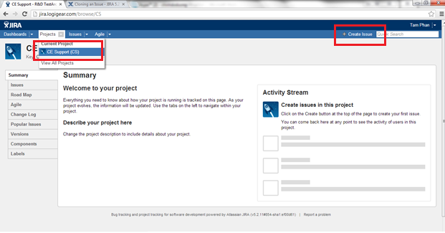

## Step 2: create issue

You must fill all required fields (marked with *)

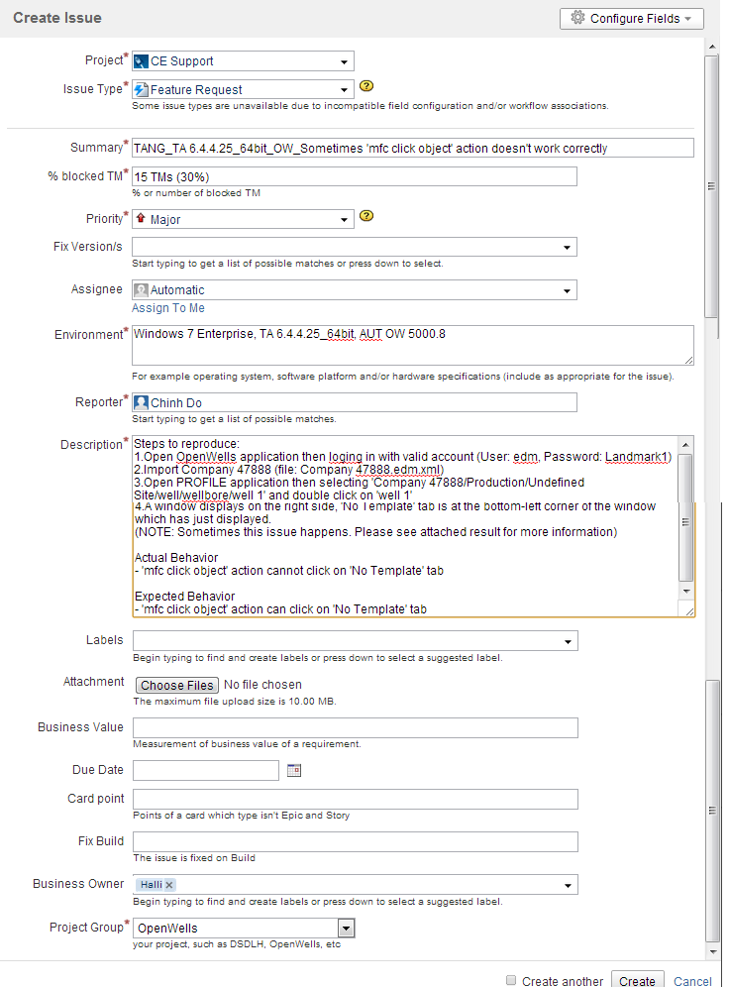

## Make sure all important fields are fulfilled

1. Issue Type:
   1. New feature request: if it is a new customized control or new action or new feature request or an improvement
   2. Bug: a feature/action that supported previously but now failed

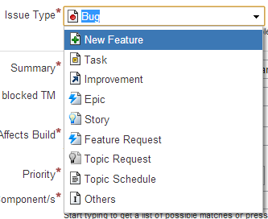

1. Affect build: TA build that you catch problem
2. Fixed version: next release that you expect your request is supported. By default, please select “not-plan”
3. Environment: OS, AUT build, TA version, harness version
4. Description: as detail as possible
   1. Precondition: AUT version, only occurs on VM or client PC, Repo/TM, etc…
   2. Step: shortest step to reproduce issue or navigate to screen that contain desired control
   3. Observer result
   4. Expected result
   5. Attachment:
      1. Screen shot of GUI/control that need to support
      2. Screen shot of TA Viewer so that we can see control’s properties
      3. If issue related to script run wrong, please attach html report to jira
      4. If issue related to result such as show wrong summary, result is blank, result of some TM is lost, please export local result folder to zip file and attach to jira too.

Step to export:

- open TAC

- right click on result node

- export

1. Project Group: your project, such as DSDBase, DSDLH, OpenWork, IMI, etc.

If your project doesn’t appear on the list, please request CE manager to add new project for you.

## Filter Issue

1. Click “Issues” -> “Search for Issues”

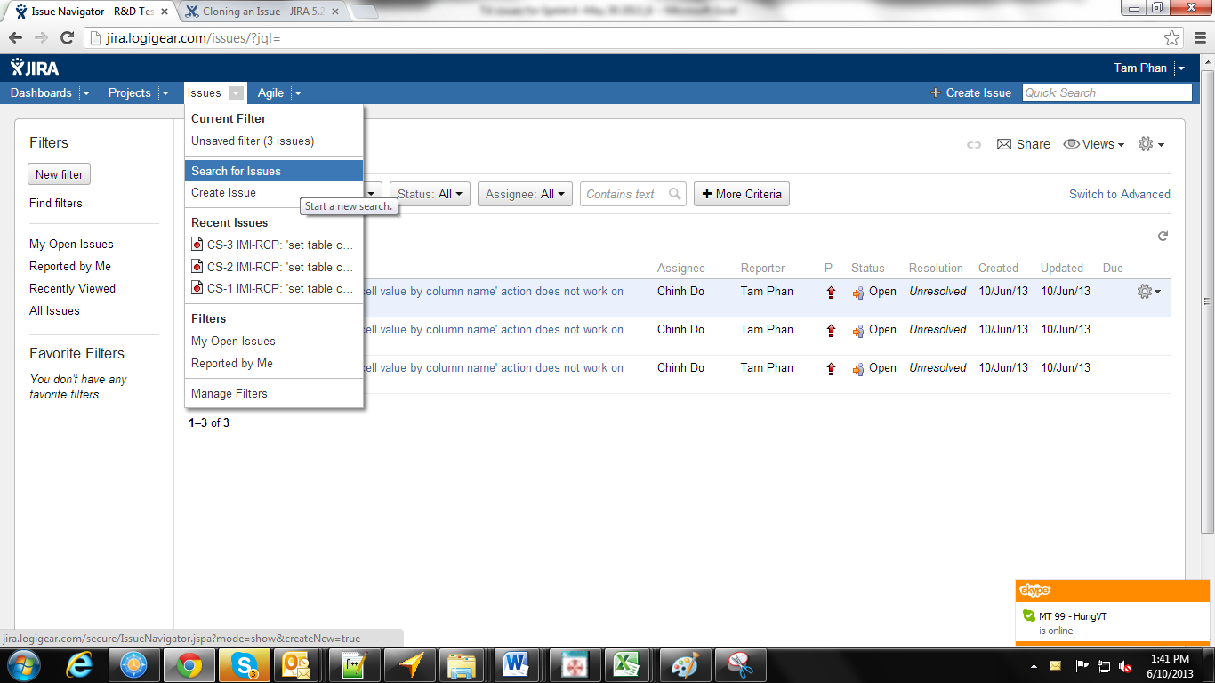

1. Filter by “Project” = “CE Support (CS)” to see all requests from all projects

Jira provide various filters for you. If you want to see all issues in a release, filter by “Fix Version/s”, if you want to see all issues of your project, filter by “Project Group”.

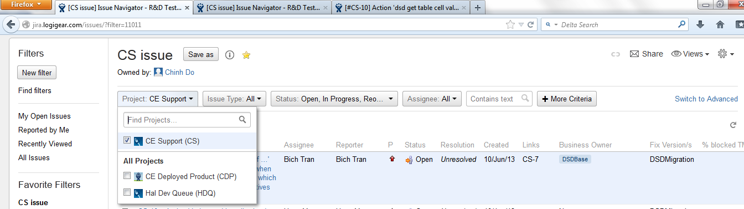

You also can switch to advance to filter by using “query statement”.

For example:

*project = CS AND "Project Group" = DSDBase*

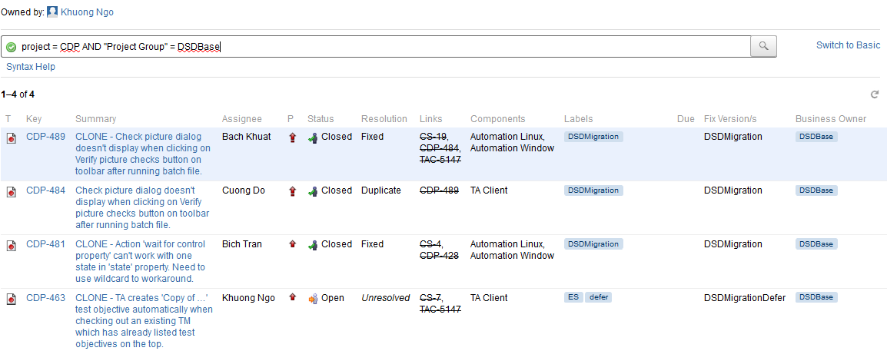

## Customize view

Add more columns in list or hide un-necessary column by going to “Configure Columns”

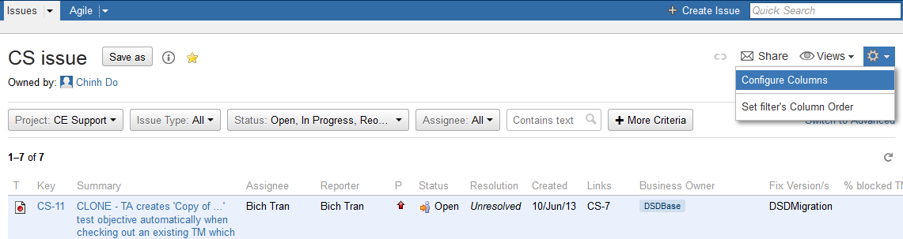

## Export to excel

